Gender-based violence Tip sheet template
The following Gender-Based Violence (GBV) Tip Sheet is a template that projects may adapt and contextualize to their implementation context. The key audience for this tip sheet includes project staff, extension agents, and others working with and engaging directly with communities. This template is adapted from resources developed by the USAID-funded Integrated Land and Resource Governance (ILRG) task order of the STARR II IDIQ.

What is GBV?
Violence that is directed at an individual based on their biological sex, gender identity, or perceived adherence to socially defined norms of masculinity and femininity. GBV takes on many forms and can occur in both private and public settings, and at any time throughout the life cycle (Schulte et al. 2014).

What are the different types of GBV?
- GBV can be physical, psychological, sexual, and economic.
GBV in [Country]
- [include a bulleted list on GBV-related statistics in the relevant context]
- [statistic x]
- [statistic y]
- [statistic z, add as many as are relevant]
Source: [Be sure to cite sources!]
- Physical assault or threat of physical assault, including domestic and intimate partner violence.
- Coercion, verbal abuse, and controlling behaviors, such as controlling mobility, social interactions, and reproductive life.
- Sexual assault and rape, including marital or spousal rape.
- Acid attacks, female feticide and infanticide, child marriage, honor killings, trafficking, forced marriage, and forced prostitution.
- Online violence including harassment, stalking, threats, defamation, and sharing of private images or videos without consent via email, phone, chats, video, and social media.
- Unwanted sexual advances or sexual harassment in the workplace or in public institutions, including demanding sexual favors or relations in return for certain benefits or to avoid retaliation.
- Economic violence including limitations to inheritance and ownership rights, restricting decision-making on earnings, and restricting access to financial resources, education, or the labor market.

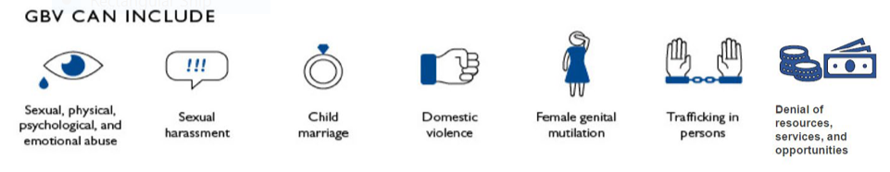

Important laws in [country] related to GBV
Title of law. Brief description of the law
Title of law. Brief description of the law
Title of law. Brief description of the law

What can we do to address GBV?
In your role working closely with communities, you may encounter disclosures of GBV. In the event that someone discloses to you:
- Respond with an empathetic ear and non-judgmental attitude. Refer to Annex 7A of the Toolkit to Address Gender-Based Violence in Agriculture and Market Systems Development for do’s and don’ts and suggestions of what to say.
- Maintain confidentiality and privacy. When a survivor reports GBV, they may be at risk of backlash from the GBV perpetrator or others. The survivor may also be socially stigmatized. Because of this, any interaction where GBV is disclosed must be kept private and steps to help the survivor should be confidential.
- Share and connect the survivor with contact information of local organizations that provide support to those who have experienced or are currently experiencing violence. Specialized GBV services may include legal, health, and socio-emotional support.
- Respect the survivor’s wishes whether they choose to report or not and whether they decide to seek support services.

Points of contact for GBV support Services
Tips for contextualizing this section: Consider using the worksheet in Annex 8 of the Toolkit for developing this section of the tip sheet. Some examples of types of organizations to include are:
- Ministry of Women and Children, local office (if any)
- Local GBV or domestic violence hotline/helpline number
- Local shelters specifically for those experiencing GBV
- Local human rights or legal services that work with those experiencing violence (if any)
- Local child protection services
- Other local organizations providing specialized services for those experiencing GBV
Organization. Contact name (if any) Phone number
Organization. Contact name (if any) Phone number
Organization. Contact name (if any) Phone number
[add as many as you find relevant]

